National University of Computer & Emerging Sciences, Karachi

Computer Science Department
Fall 2022, Lab Manual - 01
Course Code: SL3001 | Course : Software Development and construction
Instructor : | Miss Nida Munawar

Lab # 02

Super Keyword in Java
The super keyword in Java is a reference variable which is used to refer immediate parent class object.
Whenever you create the instance of subclass, an instance of parent class is created implicitly which is referred by super reference variable.

Usage of Java super Keyword
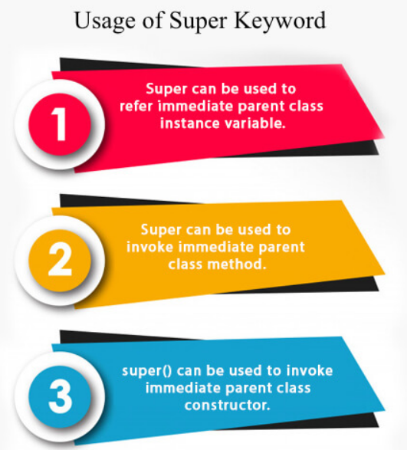

super is used to refer immediate parent class instance variable.
We can use super keyword to access the data member or field of parent class. It is used if parent class and child class have same fields.

class Animal{
String color="white";
}
class Dog extends Animal{
String color="black";
void printColor(){
System.out.println(color);//prints color of Dog class
System.out.println(super.color);//prints color of Animal class
}
}
class TestSuper1{
public static void main(String args[]){
Dog d=new Dog();
d.printColor();
}}

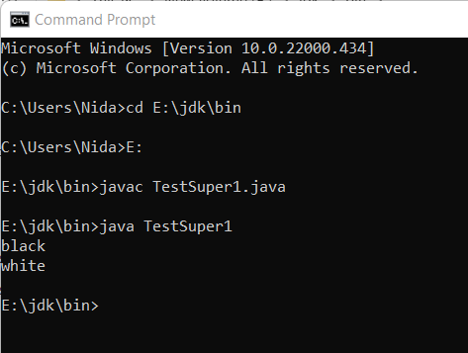

2) super can be used to invoke parent class method
The super keyword can also be used to invoke parent class method. It should be used if subclass contains the same method as parent class. In other words, it is used if method is overridden.

class Animal{
void eat(){System.out.println("eating...");}
}
class Dog extends Animal{
void eat(){System.out.println("eating bread...");}
void bark(){System.out.println("barking...");}
void work(){
super.eat();
bark();
}
}
class TestSuper2{
public static void main(String args[]){
Dog d=new Dog();
d.work();
}}

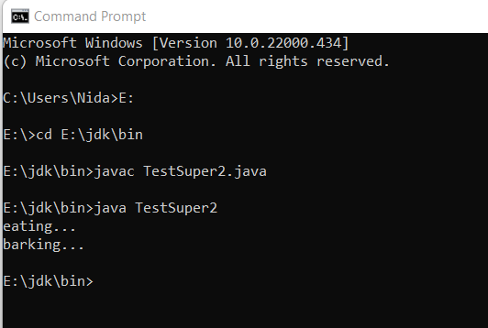

3) super is used to invoke parent class constructor.

Note: super() is added in each class constructor automatically by compiler if there is no super() or this().

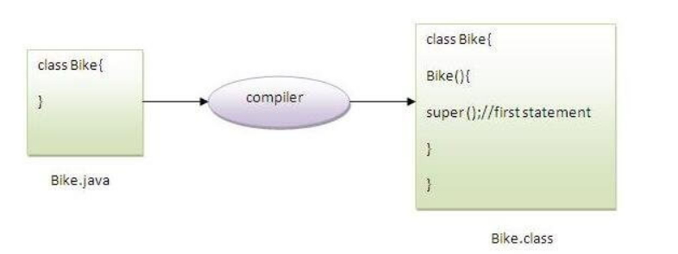

example of super keyword where super() is provided by the compiler implicitly.

class Animal{

Animal(){System.out.println("animal is created");}

}

class Dog extends Animal{

Dog(){

System.out.println("dog is created");

}

}

class TestSuper2{

public static void main(String args[]){

Dog d=new Dog();

}}

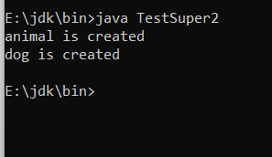

example of super keyword where super() is provided explicitly

class Animal{

Animal(){System.out.println("animal is created");}

}

class Dog extends Animal{

Dog(){

super();

System.out.println("dog is created");

}

}

class TestSuper2{

public static void main(String args[]){

Dog d=new Dog();

}}
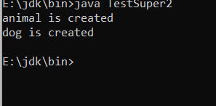
Real usage of super
class Person{
int id;
String name;
Person(int id,String name){
this.id=id;
this.name=name;
}
}
class Emp extends Person{
float salary;
Emp(int id,String name,float salary){
super(id,name);//reusing parent constructor
this.salary=salary;
}
void display(){System.out.println(id+" "+name+" "+salary);}
}
class TestSuper2{
public static void main(String[] args){
Emp e1=new Emp(1,"Nida",45000f);
e1.display();
}}
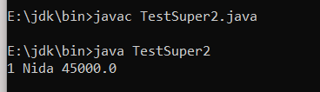

Abstraction:
Abstraction aims to hide complexity from the users and show them only the relevant information. For example, if you want to drive a car, you don’t need to know about its internal workings. The same is true of Java classes. You can hide internal implementation details by using abstract classes or interfaces. On the abstract level, you only need to define the method signatures (name and parameter list) and let each class implement them in their own way.
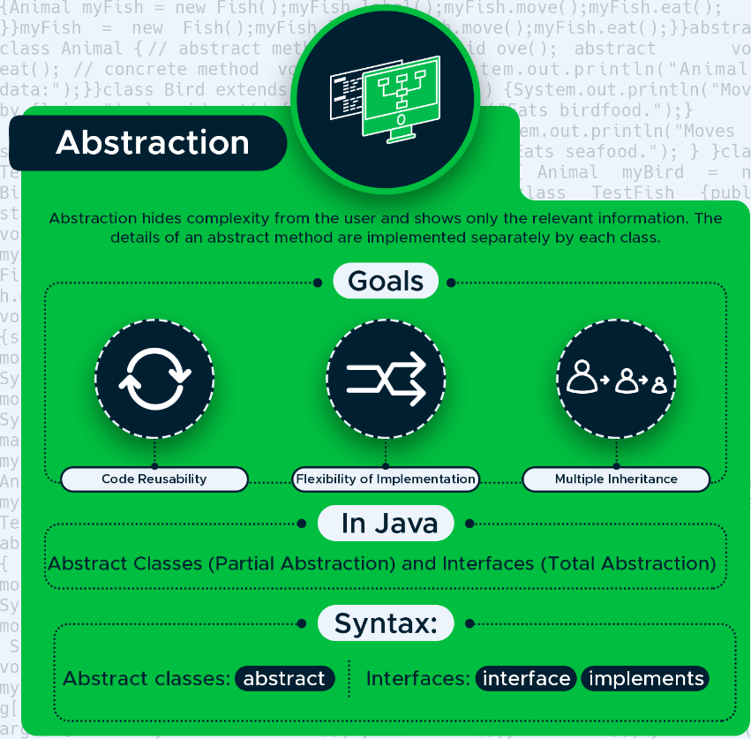

With abstraction, you can hide the internal workings of an object and only show the features the user needs to know about. Java provides two ways to implement abstraction: abstract classes and interfaces. With abstract classes, you can achieve partial abstraction, while interfaces make total (100%) abstraction possible.

Abstract classes
An abstract class is a superclass (parent class) that cannot be instantiated. You need to instantiate one of its child classes if you want to create a new object. Abstract classes can have both abstract and concrete methods. Abstract methods contain only the method signature, while concrete methods declare a method body as well. Abstract classes are defined with the abstract keyword.
In the example below, you can see an abstract class called Animal with two abstract and one concrete method.
abstract class Animal {
// abstract methods
abstract void move();
abstract void eat();

// concrete method
void label() {
System.out.println("Animal's data:");
}
}

Extend the Animal abstract class with two child classes: Bird and Fish. Both of them set up their own functionality for the move() and eat() abstract methods.
class Bird extends Animal {

void move() {
System.out.println("Moves by flying.");
}
void eat() {
System.out.println("Eats birdfood.");
}
}

class Fish extends Animal {
void move() {
System.out.println("Moves by swimming.");
}
void eat() {
System.out.println("Eats seafood.");
}
}

Now, test it with the TestBird and TestFish classes. Both call the one concrete (label()) and the two abstract (move() and eat()) methods.
class TestBird {
public static void main(String[] args) {
Animal myBird = new Bird();
//you can create reference of abstract class
myBird.label();
myBird.move();
myBird.eat();
}
}

class TestFish {
public static void main(String[] args) {
Animal myFish = new Fish();

myFish.label();
myFish.move();
myFish.eat();
}
}

Interfaces
An interface is a 100% abstract class. It can have only static, final, and public fields and abstract methods. It’s frequently referred to as a blueprint of a class as well. Java interfaces allow us to implement multiple inheritance in our code, as a class can implement any number of interfaces. Classes can access an interface using the implements keyword.

the Java compiler adds public and abstract keywords before the interface method. Moreover, it adds public, static and final keywords before data members.

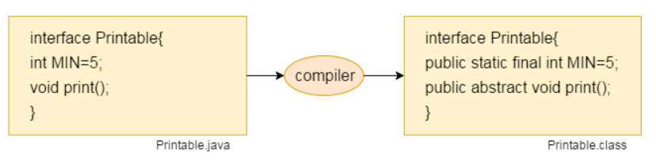
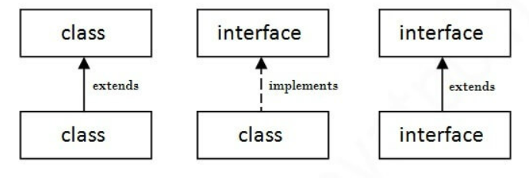
In the example, define two interfaces, Animal and Bird. Animal has two abstract methods, while Bird has two static fields and an abstract method.
interface Animal {
public void eat();
public void sound();
}

interface Bird {
int numberOfLegs = 2;
String outerCovering = "feather";

public void fly();
}

The class Eagle implements both interfaces. It defines its own functionality for the three abstract methods. The eat() and sound() methods come from the Animal class, while fly() comes from Bird.
class Eagle implements Animal, Bird {
public void eat() {
System.out.println("Eats reptiles and amphibians.");
}
public void sound() {
System.out.println("Has a high-pitched whistling sound.");
}
public void fly() {
System.out.println("Flies up to 10,000 feet.");
}
}
In the TestEagle test class, instantiate a new Eagle object (called myEagle) and print out all the fields and methods to the console.
As static fields don’t belong to a specific object but to a whole class, you need to access them from the Bird interface instead of the myEagle object.
class TestEagle {
public static void main(String[] args) {
Eagle myEagle = new Eagle();

myEagle.eat();
myEagle.sound();
myEagle.fly();

System.out.println("Number of legs: " + Bird.numberOfLegs);
System.out.println("Outer covering: " + Bird.outerCovering);
}
}

Multiple inheritance in Java by interface
If a class implements multiple interfaces, or an interface extends multiple interfaces, it is known as multiple inheritance.
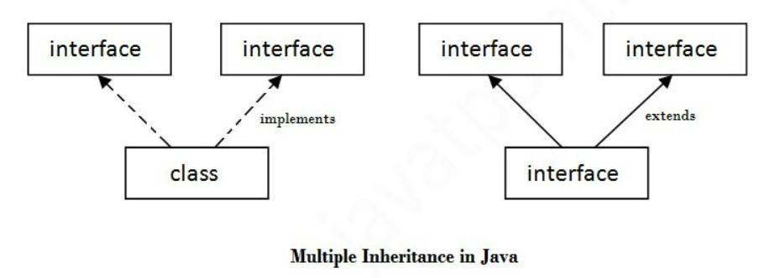

Q) Multiple inheritance is not supported through class in java, but it is possible by an interface, why?
As we have explained in the inheritance chapter, multiple inheritance is not supported in the case of class because of ambiguity. However, it is supported in case of an interface because there is no ambiguity. It is because its implementation is provided by the implementation class. For example:
interface Printable{
void print();
}
interface Showable{
void print();
}

class TestInterface3 implements Printable, Showable{
public void print(){System.out.println("Hello");}
public static void main(String args[]){
TestInterface3 obj = new TestInterface3();
obj.print();
}
}
Output:
Hello
As you can see in the above example, Printable and Showable interface have same methods but its implementation is provided by class TestTnterface1, so there is no ambiguity.

Interface inheritance
A class implements an interface, but one interface extends another interface.
interface Printable{
void print();
}
interface Showable extends Printable{
void show();
}
class TestInterface4 implements Showable{
public void print(){System.out.println("Hello");}
public void show(){System.out.println("Welcome");}

public static void main(String args[]){
TestInterface4 obj = new TestInterface4();
obj.print();
obj.show();
}
}

Java 8 Default Method in Interface
Since Java 8, we can have method body in interface. But we need to make it default method. Let's see an example:
interface Drawable{
void draw();
default void msg(){System.out.println("default method");}
}
class Rectangle implements Drawable{
public void draw(){System.out.println("drawing rectangle");}
}
class TestInterfaceDefault{
public static void main(String args[]){
Drawable d=new Rectangle();
d.draw();
d.msg();
}}
drawing rectangle
default method

Java 8 Static Method in Interface
Since Java 8, we can have static method in interface. Let's see an example:
interface Drawable{
void draw();
static int cube(int x){return x*x*x;}
}
class Rectangle implements Drawable{
public void draw(){System.out.println("drawing rectangle");}
}

class TestInterfaceStatic{
public static void main(String args[]){
Drawable d=new Rectangle();
d.draw();
System.out.println(Drawable.cube(3));
}}
An Example of Diamond Problem with Default Methods

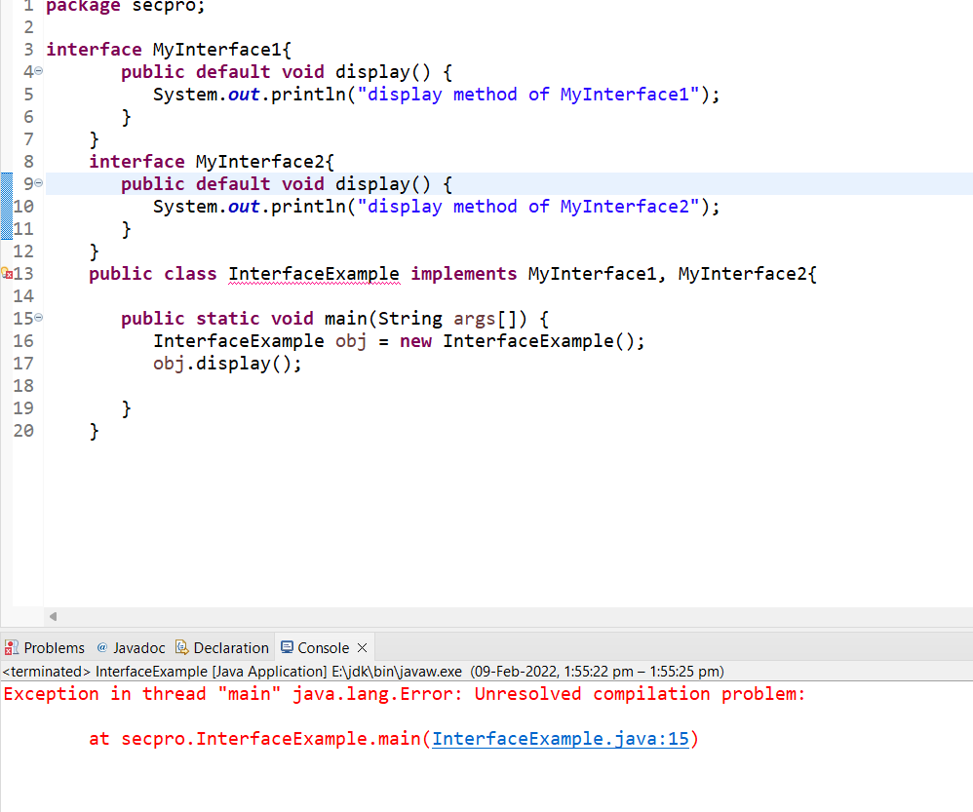
Solution: to overcome with this error override the duplicated method in InterfaceExample
An Example of Diamond Problem with Default Methods
interface MyInterface1{
int num = 100;
public default void display() {
System.out.println("display method of MyInterface1");
}
}
interface MyInterface2{
int num = 1000;
public default void display() {
System.out.println("display method of MyInterface2");
}
}
public class InterfaceExample implements MyInterface1, MyInterface2{
public void display() {
MyInterface1.super.display();
//or,
MyInterface2.super.display();
}
public static void main(String args[]) {
InterfaceExample obj = new InterfaceExample();
obj.display();
System.out.println(MyInterface1.num);//fields are by default static and we can not use super with static
}
}
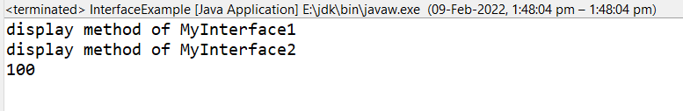
An Example of Diamond Problem with static Methods
package secpro;

interface MyInterface1{
int num = 100;
public static void display() {
System.out.println("display method of MyInterface1");
}
}
interface MyInterface2{
int num = 1000;
public static void display() {
System.out.println("display method of MyInterface2");
}
}
public class InterfaceExample implements MyInterface1, MyInterface2{
public void display() {
MyInterface1.display();//we can not use super with static
//or,
MyInterface2.display();
}
public static void main(String args[]) {
InterfaceExample obj = new InterfaceExample();
obj.display();
System.out.println(MyInterface1.num);//fields are by default static and we can not use super with static
}
}


Why can't we use the "super" keyword is in a static method in java?

Why can't we use the "this" keyword is in a static method in java?

Why can't we use the "super" and “this” keyword in a constructor in java?

Polymorphism

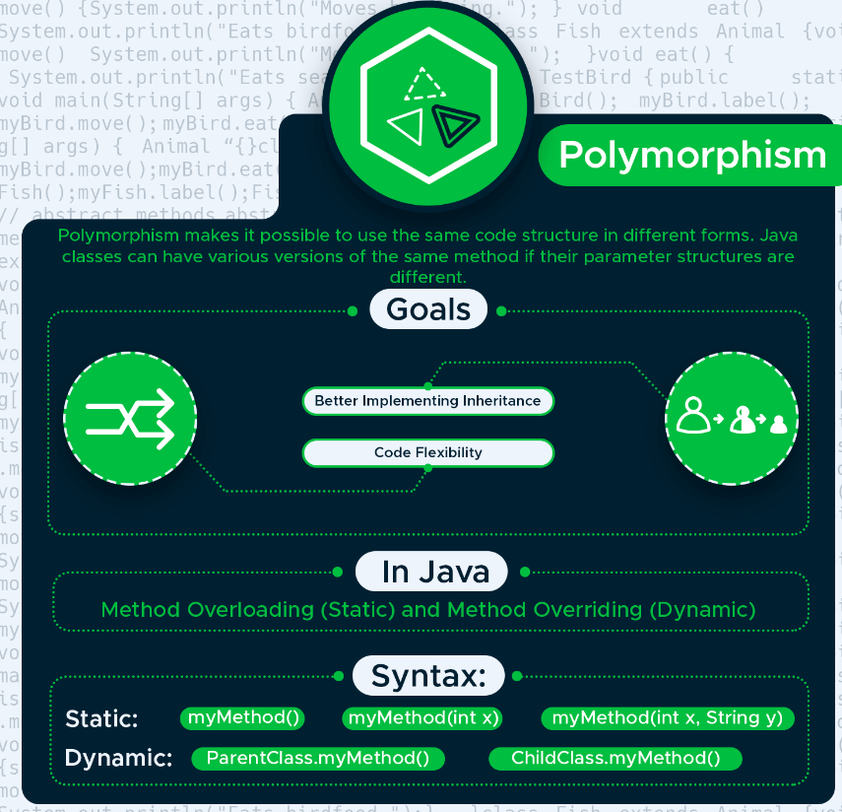

Polymorphism makes it possible to use the same entity in different forms. In Java, this means that you can declare several methods with the same name until they are different in certain characteristics. Java provides us with two ways to implement polymorphism: method overloading and method overriding.

Static polymorphism
Method overloading means that you can have several methods with the same name within a class. However, the number, names, or types of their parameters need to be different.
For example, the Bird() class below has three fly() methods. The first one doesn’t have any parameters, the second one has one parameter (height), and the third one has two parameters (name and height).
class Bird {
public void fly() {
System.out.println("The bird is flying.");
}
public void fly(int height) {
System.out.println("The bird is flying " + height + " feet high.");
}
public void fly(String name, int height) {
System.out.println("The " + name + " is flying " + height + " feet high.");
}
}
The test class instantiates a new Bird object and calls the fly() method three times. Firstly, without parameters, secondly, with one integer parameter for height, and thirdly, with two parameters for name and height.
class TestBird {
public static void main(String[] args) {
Bird myBird = new Bird();

myBird.fly();
myBird.fly(10000);
myBird.fly("eagle", 10000);
}
}

Dynamic polymorphism

Dynamic Polymorphism or DMD
Dynamic polymorphism is a process or mechanism in which a call to an overridden method is to resolve at runtime rather than compile-time. It is also known as runtime polymorphism or dynamic method dispatch. We can achieve dynamic polymorphism by using the method overriding.
In this process, an overridden method is called through a reference variable of a superclass. The determination of the method to be called is based on the object being referred to by the reference variable.
package secpro;

//parent class
class Fruits
{
public void color()
{
System.out.println("Parent class method is invoked.");
}
}
//derived or child class that extends the parent class
class Mango extends Fruits
{
//overrides the color() method of the parent class
public void color()
{
System.out.println("The child class method is invoked.");
}
}
public class DynamicPolymorphismExample
{
public static void main(String args[])
{
//assigning a child class object to a parent class reference
Fruits fruits = new Mango();
//invoking the method
fruits.color();
}
}
